Access Statement

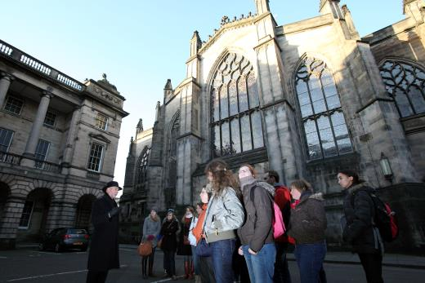

Contents

Welcome 3

Reaching Us 5

Main Entrance, Reception and Ticketing Area 8

Mercat Cross Ticketing Outlet 10

Attraction 11

Discovery Room 17

Additional Information 19

Future Plans & Feedback 19

Contact Details 20

This access statement does not contain personal opinions as to our suitability for those with access needs, but aims to accurately describe the facilities and services that we offer all our guests / visitors.

Welcome
Mercat Tours is situated in the heart of Edinburgh's medieval Old Town. We are a five star history and ghost tour company, and have maintained this prestigious award from Visit Scotland since 2007, achieving some of the highest scores among Scottish attractions. We have won numerous industry awards during our 30 years of operation in the Old Town and we continually review and revise our products in line with visitor feedback.
All our walking tours start at the Mercat Cross, situated in the High Street, on a wide area of pavement beside St Giles Cathedral, which can be reached from North Bridge by walking up a slight incline, or from George IV Bridge, on a level route with slight incline.
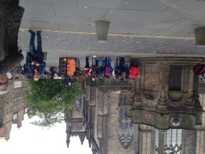
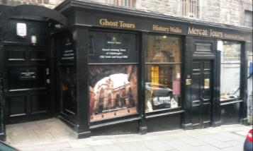

Mercat Tours Office, Blair Street Mercat Cross, High Street
Some points to note:
- All our tours explore the closes and courtyards of Old Edinburgh
- The duration varies, depending on the tour
- We have a complimentary carer ticket policy in operation
Some of our daily tours also include a visit to the Blair Street Underground Vaults, accessed from 28 Blair Street, which is situated half way down a steep hill running from the High Street to the Cowgate. Our office is also situated at this location.

We operate daily tours which visit the Canongate Graveyard and Edinburgh Castle, both of which are reached via steep slopes, and have uneven pathways.
The Blair Street Underground Vaults are situated down 3 flights of stairs. The vaults are on one level but the ground is uneven in parts, as the original flooring is still in use.
Tours which visit the Underground Vaults visit our Discovery Room. The Discovery Room contains interactive displays and further information boards.
Our office and Discovery Room are located at street level. There are 3 steps down to the corridor which leads to the latter two areas.
We operate tours all year, except 24-26 December.
Guides can devise wheelchair accessible routes in the Old Town. They can also devise routes which avoid steep slopes and stepped areas. If visitors have particular needs in this respect, they should make the guide aware before the start of the tour and the guides are trained, and happy to help.
We have guaranteed departures, even in poor weather, and all our guides are happy to answer further questions from visitors as they arise.
We offer written transcripts of all our tours in English, French, German, Spanish, Italian, Russian and Mandarin.
There is the opportunity to see and touch artefacts from the Blair Street Underground Vaults in the Discovery Room at the end of tours.
We look forward to welcoming you. If you have any queries or require any assistance please phone +44 (0)131 225 5445 or email info@mercattours.com

Reaching Us
For full details on how to reach us please see our website www.mercattours.com and follow the Get In Touch link.
Train
The nearest railway station is Edinburgh Waverley, which is approximately 0.32km (5-10 minute walk).
Taxis are available from outside the station on Market Street and Waverley Bridge. The Market Street rank can be reached using lifts if required. Full station facilities and information about accessibility can be found at www.nationalrail.co.uk
Bus:
There are frequent bus services which stop near our office and departure point. The nearest bus stops are:
North Bridge (for services 3, 5, 7, 8, 14, 30, 31, 33, 35, 37, 45, 47, 49, Perrymans 51 / 52 and First Bus X95)
George IV Bridge (for services 23, 27, 41, 42).
All bus stops on North Bridge and George IV Bridge have shelters and seating.
Further information on bus services, times and fares can be found at www.lothianbuses.com.
All Lothian buses are wheelchair accessible. Information about accessibility can be found at: www.lothianbuses.com
Other websites Perryman: www.perrymansbuses.co.uk and First Group www.firstgroup.com
Tram:
The nearest tram stop is St Andrew’s Square and the Accessibility Link is: http://edinburghtrams.com/community/tram-access
Taxi:
Central Taxis offer accessible taxis and can be contacted on www.taxis-edinburgh.co.uk 0131 229 2468
Car:
There is pay and display on-street car parking available on Blair Street, Cowgate, Blackfriars Street and Chambers Street.
Blair Street is closest to our meeting point and office, but parking can be limited and only the left hand side of the street available for pay and display.
There are approximately 10 spaces. The surface of the street is cobbled and very uneven in places.
There are no parking charges on Sundays or after 1830, daily.
There is a ticket machine on Blair Street, 5 meters from the entrance to the Mercat Tours office.
You can also pay using ringo, by phone or mobile app. Instructions are located on the ticket machine.
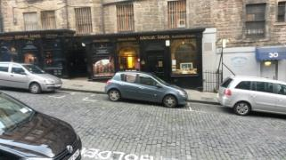
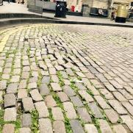

Blair Street Blair Street
There are no assigned disabled parking bays on Blair Street. Blue Badge holders can park in public bays without time limit or charge.
The Blair Street kerbs vary from 152 -254 mm in depth. There are very uneven cobbles on the street directly outside the IBIS hotel which are potential trip hazards.

There is secure parking available at:
St John's Hill (NCP)
Radisson Blu Hotel
Castle Terrace (NCP)
New Street (NCP)
These car parks all have lifts.
Vehicle access to the Mercat Cross is via George IV Bridge.
There is no vehicular access from North Bridge.
Drop off Point:
There is no parking at the Mercat Cross although you may be able drop off visitors briefly and park elsewhere. Leave plenty of time if you choose to do this.
Tour Start Point:
The routes to the tour start point (Mercat Cross) and office (Blair Street) are primarily cobbled and paved. Blair Street has a number of uneven areas of pavement, which occasionally are blocked when Lorries are making deliveries. You do not have to come to our office to buy tickets. Tickets are available online at www.mercattours.com , at the tour meeting point, the Mercat Cross, which is staffed from 10am -12 noon, 1.15pm - 6.15pm and 6.45pm - 10.15pm daily, or by phone 0131 225 5445.
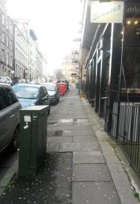
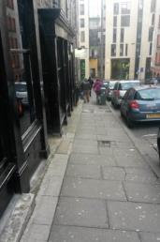
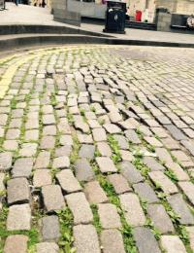

Main Entrance, Reception and Ticketing Area
Our office is open:
9am - 6pm Monday – Friday
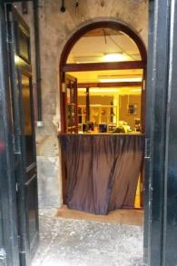
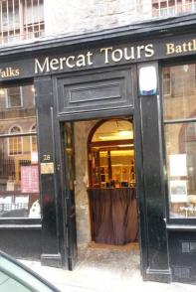
10am - 6pm Saturday and Sunday.
Office Entrance Office Entrance
Access to the office is via Blair Street through a single black door:
508mmwide.
Can be widened to 1041mm on request.
The reception area is step-free, but with a slight lip of 20mm / 1 inch at the black entrance door.
The floor surface is stone slab.
There are windows on 3 out of 4 sides of the reception area, providing natural light.
If the weather is inclement, there are also ceiling spotlights which provide additional lighting.
There are two possible reception desks.
The permanent reception area is to the left and the desk is 1168mm high.
The temporary area is directly ahead of the main entrance and is the same height. The temporary desk can be removed should anyone require a lower reception area to facilitate communication between customers and staff.
There is no glass divider between the reception and ticket sales.
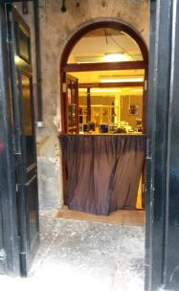
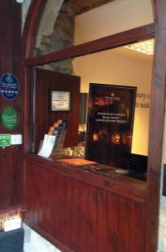
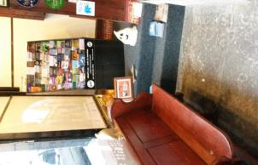
Reception Area Seating Reception Desk 1 Reception Desk 2
There is a wooden bench for seating available in the reception area and local attraction brochures to browse.
We have an induction loop installed.
The area is lit with LED bulbs and fluorescent lights.
There is no background music.
City maps are available on request in English, French, German, Italian and Spanish.
Prices are displayed in our reception area, and also on our external window. Our staff are happy to clarify any prices on request. We have pen and paper and magnifying glasses readily available. We accept cash, credit and debit cards.
The card terminal can reach over the reception desk if required.

Mercat Cross Ticket Outlet
You can also purchase tickets at the Mercat Cross before tours, although we always recommend purchasing tickets in advance. For staffed hours at the Mercat Cross, see Pre Arrival above.
Mercat Tours has clearly branded boards with a black metal frame, adjacent to the Mercat Cross.
It is on a wide paved area.
There are stone bollards at the edge of the paved area, approximately 450mm.
Our team members are clearly identifiable with Mercat Brand black jackets and badges. They can assist visitors with questions, advice or sales.
We accept cash, credit and debit cards at the Mercat Cross.

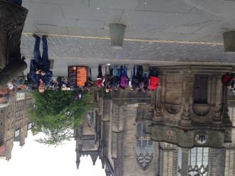

Mercat Cross, meeting point

Attraction
Our tours are performed by a live guide using storytelling skills, occasional illustrations and props to enhance the experience for visitors.
The group size is capped at 30 people for all tours.
Tour in the Old Town
The tour routes vary as guides adapt the tour to external circumstances, group needs and time. We endeavor to use information as close to relevant sites as possible.
The Old Town is comprised mainly of cobbled streets, paved areas and steep slopes.
Kerbs can be uneven in places.
Where there are particular hazards or weather issues, the guide will give the group due warning and guidance, or avoid completely.
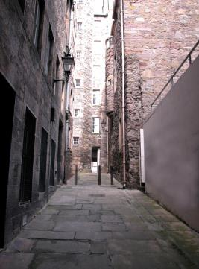
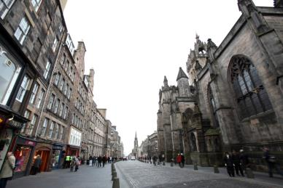

Royal Mile

Cobbled Close

There may be occasional seating available during the tour on the High Street, but it is not guaranteed.
Walking aids and stick stools can be requested in advance and returned at the end of the tour.
Guides are trained to adapt tours for those with particular needs in order to provide the fullest possible experience.
The guide will adapt the tour route to suit those using wheelchairs.
The guide will include more descriptions for those with sight impairment.
The guide will ensure that they are in the right position to communicate with those people with hearing difficulties –and will discuss all needs and respond according to personal preferences in terms of delivery.
The guide will annunciate words clearly and slow the commentary to allow translation, but without having an impact on the tour experience.
A written transcript of all our tours in English, French, German, Spanish, Italian, Russian and Mandarin

Tour in the Blair Street Underground Vaults
If the tour includes the Blair Street Underground Vaults, these are accessed through a door 1092mm.
There is automatic lighting above the entrance which is triggered each time the door is opened.

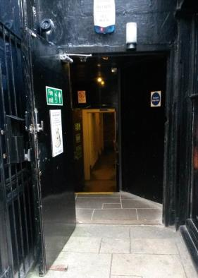
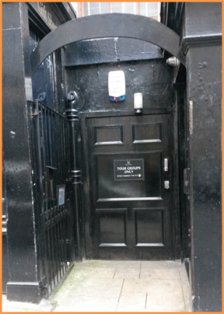
Entrance to Blair Street Underground Vaults

There are 3 steps (160mm height per step) into the main upper corridor area, with handrails to the left and right.
The route to the vaults is through a doorway 711mm wide, down three sets of steps, one of 12 steps (curved, handrail to left), then 2 steps (straight, handrails both sides) and finally 15 steps (curved, handrail to left). The stairwell is 1092mm wide.
The steps are relatively even in size.
Each step is painted with yellow paint to increase visibility.

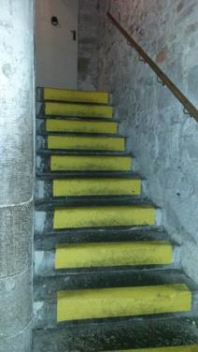
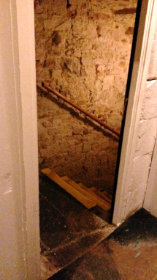
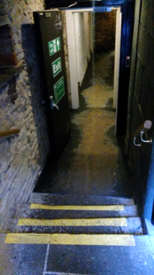

Entrance to Blair Street Underground Vaults

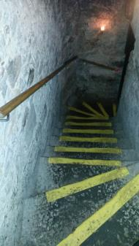
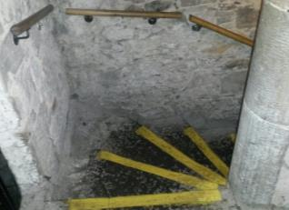
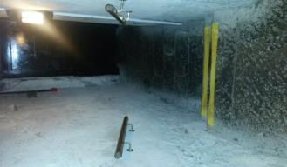 Stairs to Underground Vaults

On reaching the lower corridor within the underground vaults, it does become significantly darker, and it can take a few moments for eyes to adjust. The entrance to the Vaults at this point is 863mmThroughout the vaults, the floor is hard earth and uneven. Where there are particular hazards, including a hard-earthen ramp, the guide will use extra light to improve visibility. There are LED bulbs inset to the floor and candles at strategic points on the route.
Although the majority of doorways in the vaults are wide (approximately 1270 -1371mm), there is one narrow point where the pathway is only 585mm
There is no background noise.

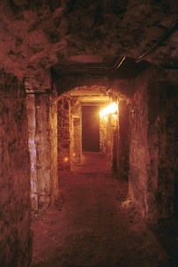
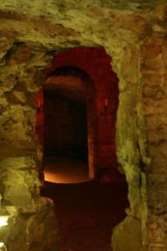
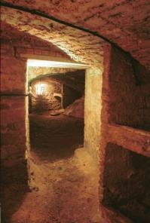
Blair Street Underground Vaults

There are two walking stick stools available for use in the vaults, for those who need additional support walking in the vaults and require rest.
The visit to the vaults can be anywhere between 30 minutes and 45 minutes, depending on the focus of the tour.
Visitors who may require additional light to provide a more comfortable vaults experience may request a torch.
Groups leave the vaults via the same route.
There is no interpretation in the Underground Vaults.
There are no steps in the Underground Vaults but the floor is uneven.

Discovery Room
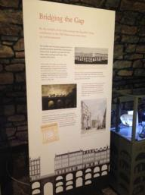
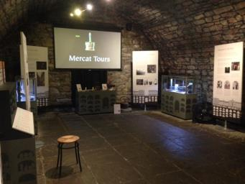
The Discovery Room is located in the main upper corridor on ground level. The room is approached via 3 stone stairs from the entrance door; steps range from 508mm to 1092mm in depth”
The floor is even throughout with flagstone floor.
Discovery Room Interpretation
In the Discovery Room, visitors have a chance to read interpretation boards, browse display cabinets, use interactive displays and watch a 5 minute audio visual presentation on the history of the vaults. There are no subtitles.
For those who are not able to visit the Underground vaults, this presentation provides a virtual tour of the rooms visited, which can be augmented with the provision of a map and information booklet.
There is limited lightweight seating without arms available in the Discovery Room.
Lighting is overhead and comprises 11 LED spotlights on two tramlines. There is also additional lighting in the display cabinets to highlight artefacts.
There is no background noise apart from the AV presentation

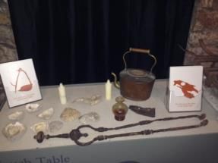
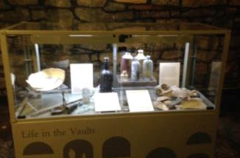
Artefacts Touch Table

There is a touch table to allow visitors to handle items found in the vaults, including old leather, shells and an iron kettle.
Visitors also have an opportunity to smell fish oil, which would have been used to light the vaults.
Guides remain in the Discovery Room to answer visitor questions or provide further information or guidance.
To exit the building, visitors leave through the main entrance door, which is up 3 steps.
The Blair Street site is not wheelchair or pushchair accessible. However, if a visitor is able to walk with assistance, we can provide storage for equipment for the duration of the tour. The guide will also allow for more time to allow safe descent into, and ascent from, the Underground Vaults.
We have an induction loop installed.

Public Toilets
There are no public toilets on site.
The nearest public toilets can be found at the top of Blair Street at Hunter Square, approximately 91m from our office.
These toilets are not wheelchair accessible and are situated down a steep flight of 10 steps.
There are handrails.
The nearest accessible toilets can be found at Edinburgh Waverley Station (5-10 minute travelling distance) or can be accessed at Radisson Blu Hotel or Starbucks (both 150 yards away).

Additional Information
All guides complete our training programme which includes guidance and discussion on how to adapt tours to visitor needs including disability awareness. There is a dedicated section in the Guide Training Manual given to all guides on joining the company.
Trained assistance dogs are welcome on tours and in the Blair Street Underground Vaults. Water will be made available on request. The nearest spending area and open space for assistance dogs is in Holyrood Park which is a fifteen minute walk.
We have a complimentary carer ticket policy in operation.
We have translation leaflets for scheduled tours and Descend & Discover, which summaries the tour content. These are available in French, German, Spanish, Italian, Russian and Mandarin.
We do not offer audio guides.
Guides can devise wheelchair accessible routes in the Old Town. They can also devise routes which avoid steep slopes and stepped areas. If visitors have particular needs in this respect, they should make the guide aware before the start of the tour.
Future Plans and Feedback
Further training for sales staff in providing an accessible visitor experience.
Include wheelchair accessible and step free routes.
Large print brochures and vaults maps developed.
Introduce interpretation panels to underground areas, with appropriate lighting.
We are always looking for ways to improve the service we provide our visitors, so please contact us if you have any comments or suggestions about this access statement or anything else that you think can improve your visit to us.

Contact Information
Address: | Mercat Tours Ltd, 28 Blair Street, Edinburgh, EH1 1QR
Telephone: | +44 (0)131 225 5445
Email: | info@mercattours.com
Website:  Facebook  Twitter | www.mercattours.com  /MercatToursLtd  @MercatToursLtd
Grid Reference: | NT 256738
Hours Of Operation: | Office 9am -6pm. Tours run 10am -10pm
Local Carers: | www.vocal.org.uk  www.ericliddell.org
Local Disabled Access Information  Local Equipment Hire: | www.euansguide.com  www.glenmoremobility.com  108B Dalry Road Edinburgh EH11 2DR +44 (0)131 337 2333
Local Accessible Taxi: | Central Taxis  www.taxis-edinburgh.co.uk
Local Public Transport: | www.lothianbuses.com  www.firstgroup.com  www.perrymansbuses.com  www.networkrail.co.uk

